TRANSFERRING THERMAL ENERGY

1. **Review from Lesson 1**

* _____________________is the measure of the total kinetic and potential energy in an object – a number value, use thermometer to measure this.
* _______________- the ____________________ of thermal energy from a __________ object to a ___________________object.
* ________________ ___________________- all substances expand with heated and contract when cooled. ___________________ is the one exception.
  + Different materials contract and expand at ____________________rates.
* _____________________________________: states that energy cannot be created or destroyed, only transferred or changed from one form to another.

1. Heat transfer is:
   * Not _________________________________
   * Transfers in __________________ direction
   * The energy _________________ moves from a ________________ area to a __________________ area.
2. Thermal energy is transferred from place to place by:

|  |  |  |
| --- | --- | --- |
| CONDUCTION | CONVECTION | RADIATION |
| __________________ of | ____________________ of thermal | _______________________of  energy by |
| thermal energy | energy in a _______________________ | ____________________________ |
| by ____________________ | by the _______________________ | ____________________________. |
| _________________ particles | of warmer and |  |
| in matter | cooler fluid from |  |
|  | place to place. |  |
|  | | |

1. Conduction
   * occurs in __________________ , ________________ , and gases.

Examples:  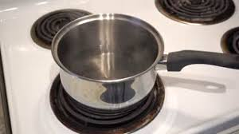 

1. Convection
   * occurs in **___________________**.
   * _________________ of _______________ fluid and _______________ of

__________________fluid forms a convection current

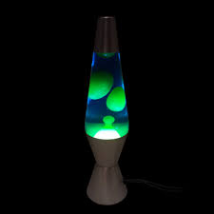

[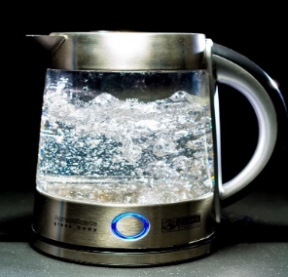](https://pixabay.com/en/kettle-glass-water-blow-geraert-357178/)Examples:

1. Radiation

* **Transfer of energy by ___________________________ _______________________**
* Does not require matter (can move through the air)

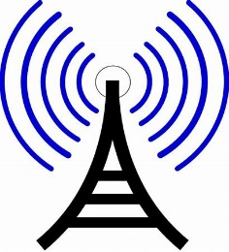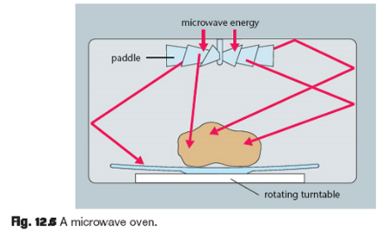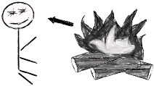

1. Energy Transformation examples
   * Sometimes, it is necessary to transform one form of energy into another for work. Write 4 examples
2. _________________________________________________________________
3. _________________________________________________________________
4. _________________________________________________________________
5. _________________________________________________________________